1. When you proceed to this step here 🡪 the phone number should be added automatically since you have already added the phone number in the previous step:

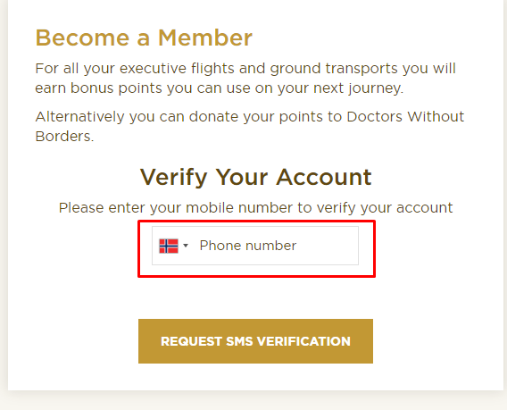

1. When you are logged into customer portal. Can you change the navigation menu so it looks like this instead:

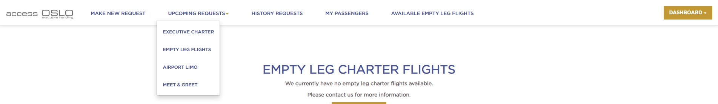

Here is the correct URL linking for navigation menu:

* **Make new Request:** <https://accessoslo.fantasylab.io/member/make-request>
* **Upcoming Requests:**
  + Executive Charter: <https://accessoslo.fantasylab.io/member/upcoming-request-type?charter=executive&status=all-status&show_mode=mode1>
  + Empty Leg Flights: <https://accessoslo.fantasylab.io/member/upcoming-request-type?charter=emptyleg&status=all-status&show_mode=mode1>
  + Airport Limo: <https://accessoslo.fantasylab.io/member/upcoming-request-type?charter=limousine&status=all-status&show_mode=mode1>
  + Meet & Greet: <https://accessoslo.fantasylab.io/member/upcoming-request-type?charter=meet&status=all-status&show_mode=mode1>
* **History Requests:**
  + Executive Charter: <https://accessoslo.fantasylab.io/member/upcoming-request-type?charter=executive&status=paid&show_mode=mode1>
  + Empty Leg Flights: <https://accessoslo.fantasylab.io/member/upcoming-request-type?charter=emptyleg&status=paid&show_mode=mode1>
  + Airport Limo: <https://accessoslo.fantasylab.io/member/upcoming-request-type?charter=limousine&status=paid&show_mode=mode1>
  + Meet & Greet: <https://accessoslo.fantasylab.io/member/upcoming-request-type?charter=meet&status=paid&show_mode=mode1>
* **My Passengers:** <https://accessoslo.fantasylab.io/member/passenger-settings>
* **Available Empty Leg Flights:** <https://accessoslo.fantasylab.io/member/empty-leg>

1. Change these options:

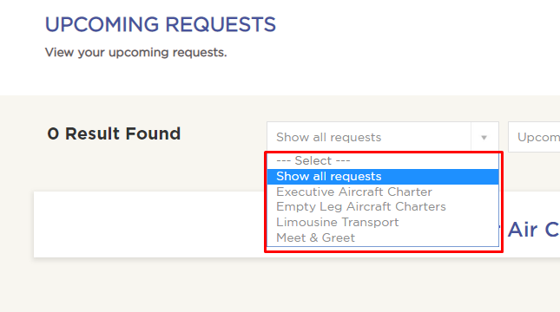

Here is the new names:

* Show all requests
* Executive Charter
* Empty Leg Flights
* Airport Limo
* Meet & Greet

1. Make this dropdown design:

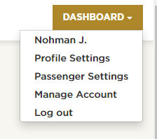

So it looks like this dropdown design instead.

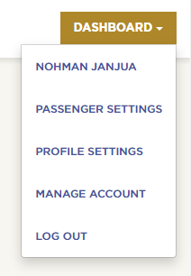

1. When you Reset your password on Reset password page, there is no system message which appear which says “Please check your email. If your user exist you will receive a reset password link”. It should look like this:

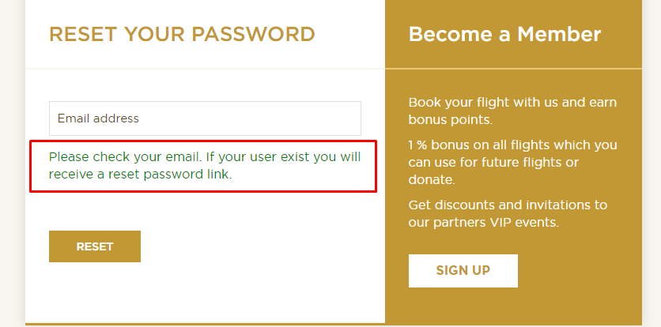

1. The reset password email link is not working:

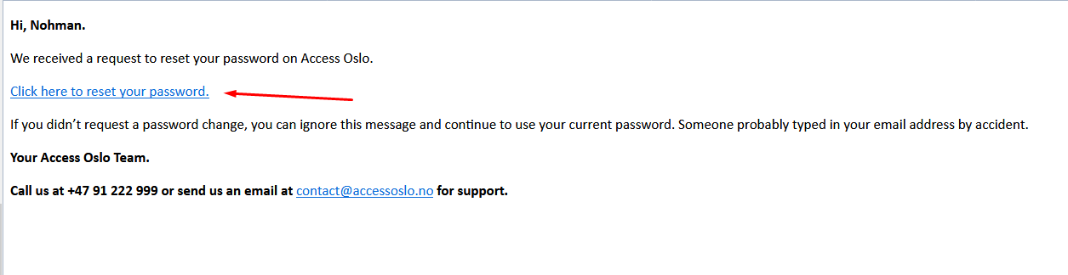

1. When you are not logged in and you fill out the Airport Limo form and click “book & pay”. The popup for login appears. After you login the step 1 popup appears. But if you close this popup, you can see that the navigation menu is not changed to DASHBOARD button, it still says Login / Free Account. It should change instantly. You don’t have to refresh the website.
2. I filled out the form on Airport Limo, but I did not complete the payment on step 3. When I go to Upcoming Requests 🡪Limousine Transport I can see this request:

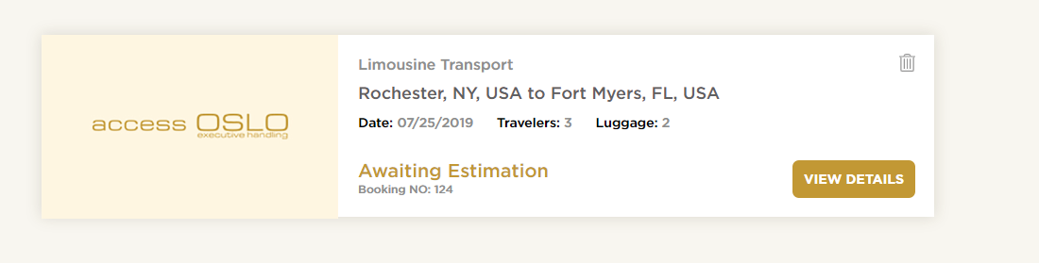

This is wrong. This request should only appear on Upcoming Requests page when you have completed the payment. Its important that the request which you need to pay for does not get added to upcoming request page. It should only get added after payment is completed.

1. On Firefox the header looks like this:

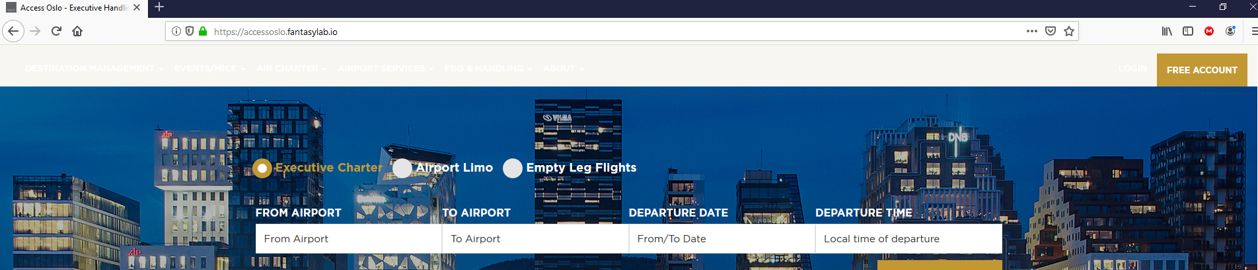

1. The Currency functionality is simply not good enough. The problem is that, when you pay with Norwegian kroners for example, then it suddenly shows Euro in Upcoming Request page. We need to change this functionality so that once you select EURO, then the pricing changes to EURO on the whole website. Currently some places its showing Norwegian kroners, some places Euro etc… This is confusing. Its better to create currency function and add it in the footer. Then from footer you can select which currency you want for the website. Or if you have any better idea let me know.
2. What is this in Airport Limo booking confirmation?

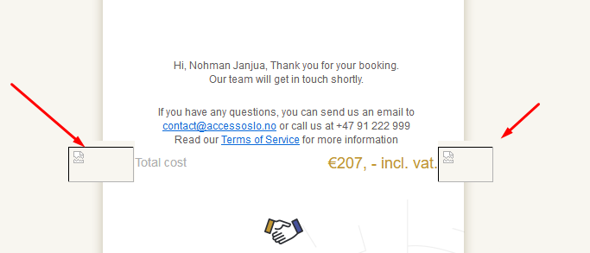

1. Here we need to add “Car Type:”

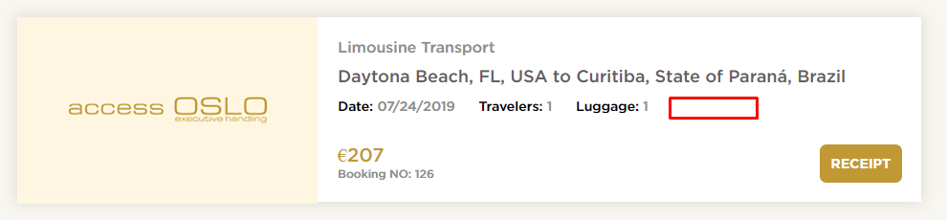

1. In Airport Limo Booking confirmation email you can remove this:

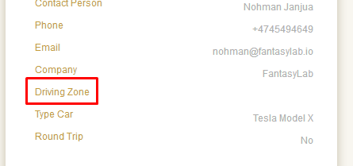

1. This link is not working in email:

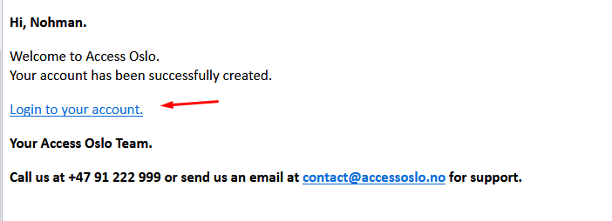

1. On home page the error message is overlapping. Does not look good. Place it under the fields:

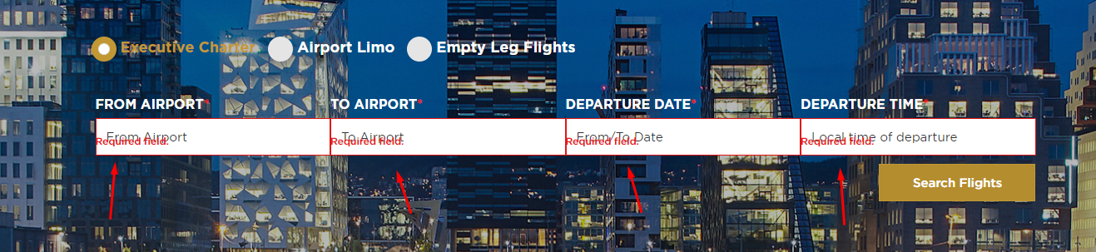

1. Newsletter it not working from Home page. If I am on Home page and I scroll down to footer and add email, I get redirected to 404 page.
2. This button is not linked to Create Account page:

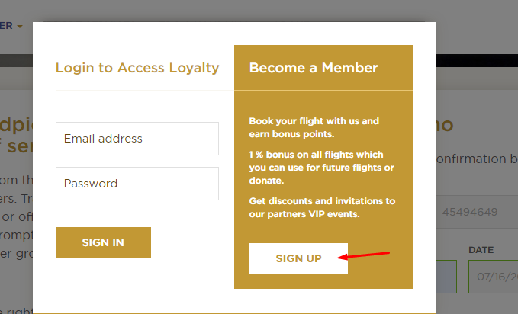

1. Remove this box shadow on empty leg charter page:

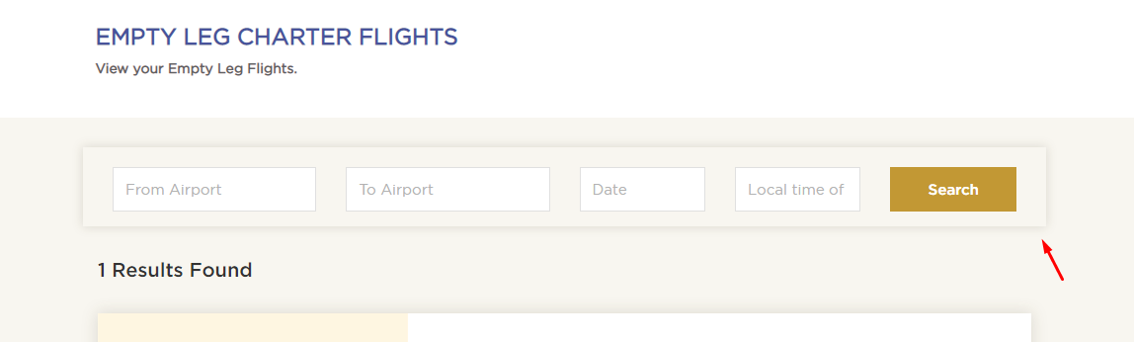

1. This link must be linked to the GDPR Privacy page:

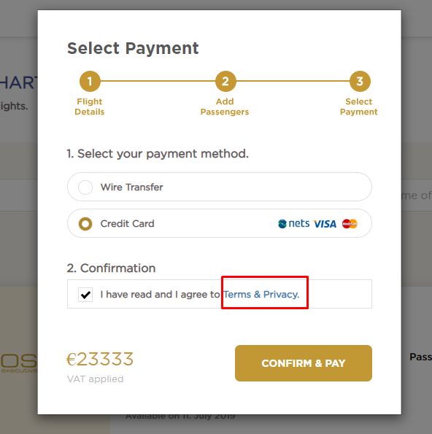

1. Add a “Status: Paid” field here for Empty Leg Flights. Just like Airport Limo:

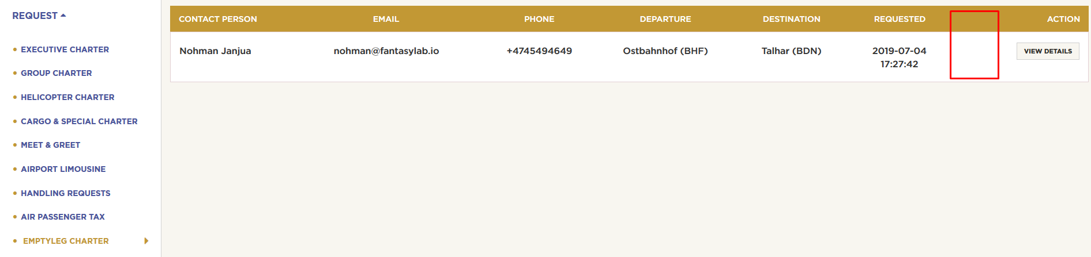

1. The image is going outside of the box:

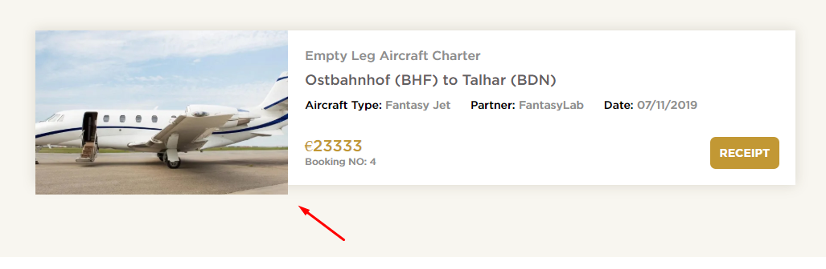

1. In the booking receipt popup, its showing this number below in screenshot. Is this number even dynamic? This should show the booking number. If its not dynamic please make it so.

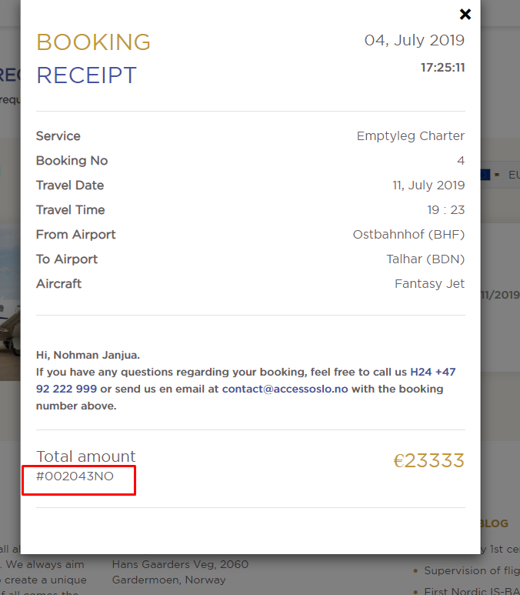

1. On this page: <https://accessoslo.fantasylab.io/empty-leg-flights> we shuld only show Empty Leg Flights. Currently its possible to select Executive Charter also. Please show only fields for Empty Leg Flights and remove this section here completely on this page:

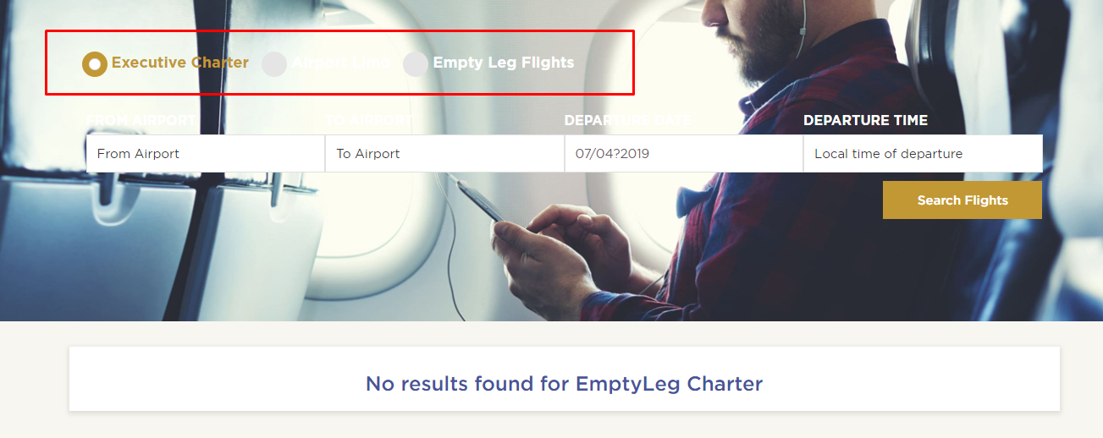

1. The way we are showing the prices is not 100% correct. Here in this screenshot you can see I have created 3 empty leg flights with different currencies:

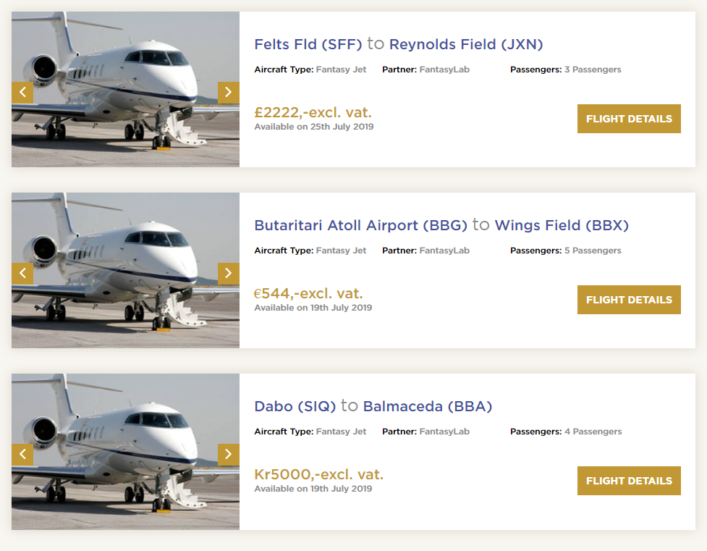

British currency is showing **£2222,-excl. vat.** This is wrong. It should be like this: **£2222 excl. vat.**

Euro currency is showing **€544,-excl. vat.** This is wrong. It should be like this: **€544 excl. vat.**

Norwegian currency showing **Kr5000,-excl. vat.** It should be like this: **kr 5000,- excl. vat.**

I have seen this issue basically everywhere when it comes to the price. Pay attention to the spacing, big/small letters. Can we fix this?

1. This number in screenshot is not dynamic. This is the booking number. Please make sure this number is dynamic for all requests:



1. On this page when you are not logged in: <https://accessoslo.fantasylab.io/empty-leg-flights> and you try to click “Flight Details” button 🡪 You get redirected to this page: <https://accessoslo.fantasylab.io/undefined>
2. On Empty Leg flights page: <https://accessoslo.fantasylab.io/empty-leg-flights> and 🡪 these fields should not be required to fill out to be able to perform a search. Only the first field must be required to make a search:

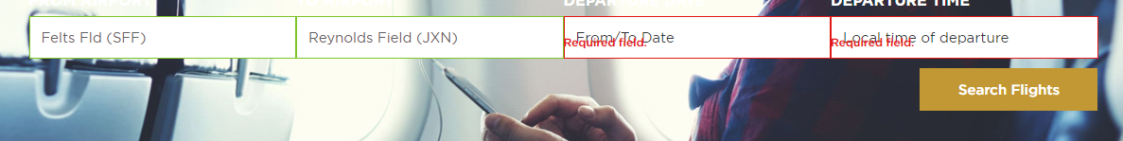

1. Remove “incl vat.” We are already showing “VAT applied” under the price:

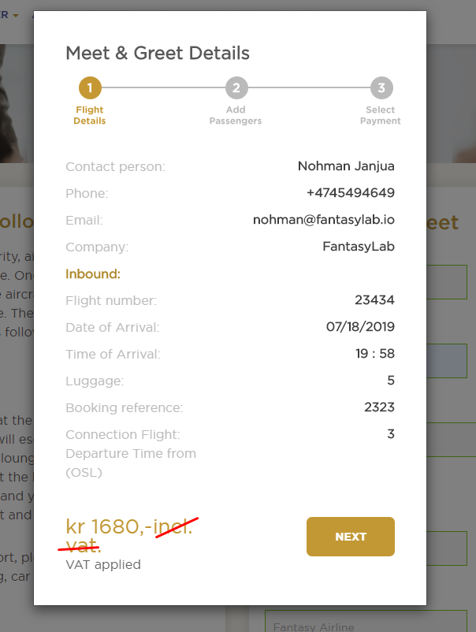

1. On Meet & Greet when you are not logged in and you try to fill out the form. A popup appears where you need to login. After I login and I proceed to step 2 to add a passenger. It does not work to add passenger. Please check this.
2. In adminpanel all tables currently have too much space between each column. This is how it looks like now:

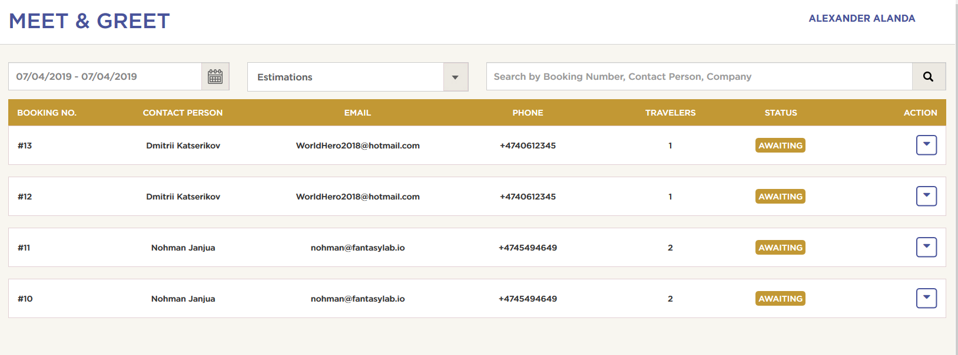

Can you remove the space so it looks like this instead:

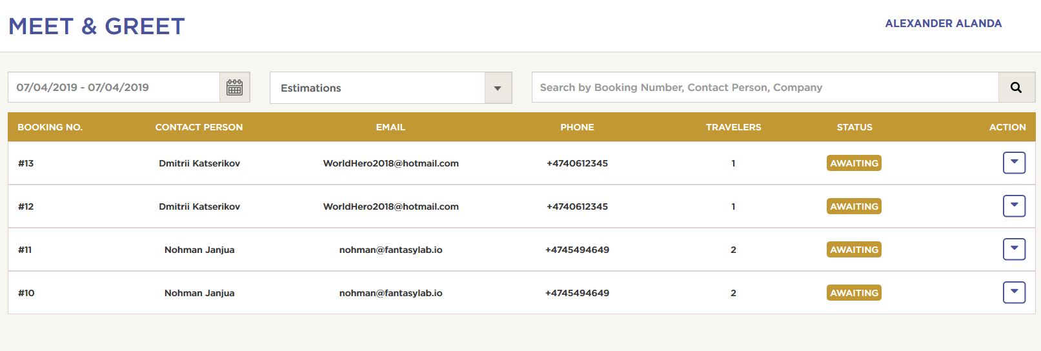

This goes out for all tables in adminpanel

1. On Air Passenger Tax page 🡪 When you fill out the form 🡪 This popup appears:

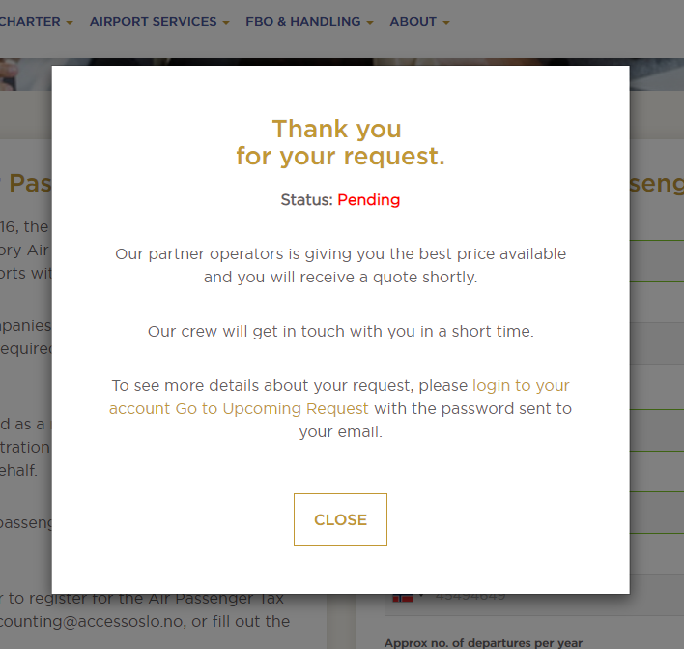

The text in this popup is wrong. Please change the text to:

**Thank you for your request.**

Our team will get in touch with you in a short time. In meanwhile if you have any questions you can send us an email to [contact@accessoslo.no](mailto:contact@accessoslo.no) or call us at +47 91 222 999.

(close button)

1. After you fill out the Handling Request form and you add a attachment. It is not possible to open the attachment from the email. This is how it looks like:

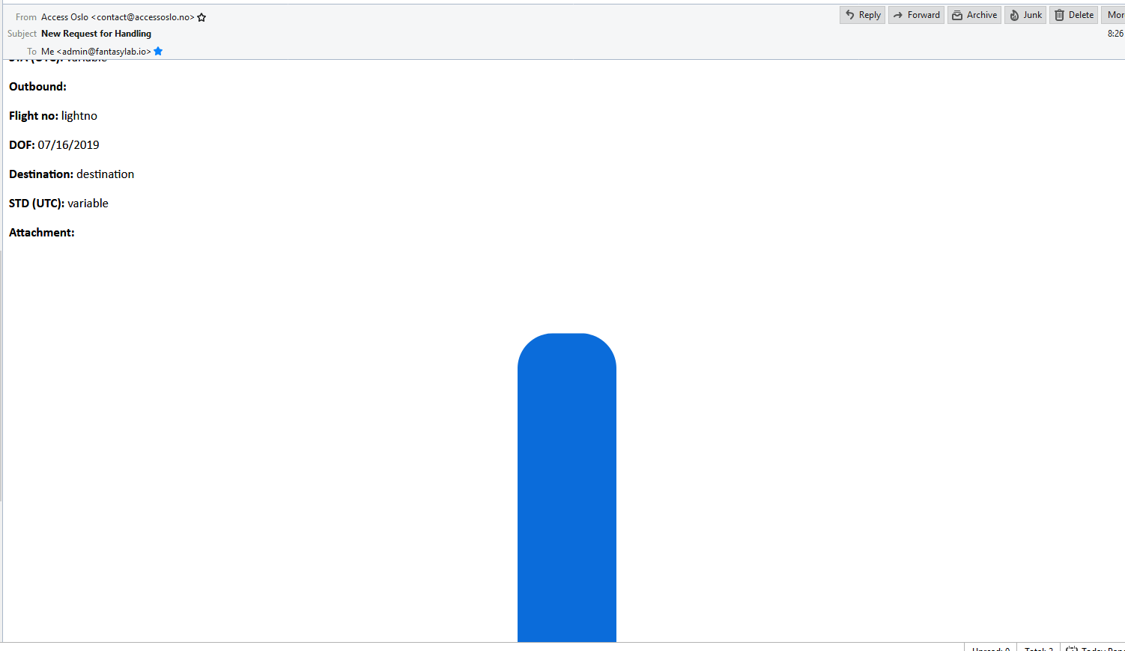

1. When filling out the meet & greet form without completing the step process 🡪 the request gets added in Upcoming Requests page. It should only be added to Upcoming Requests page after user have completed the payment. Here you can see a screenshot that the Meet & Greet requests are showing even if I have not paid for it:

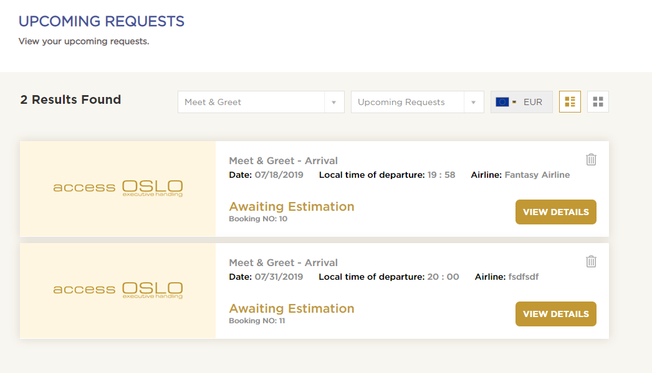

1. In adminpanel 🡪 Requests 🡪 Meet & Greet we do not need this section here. Please remove it:

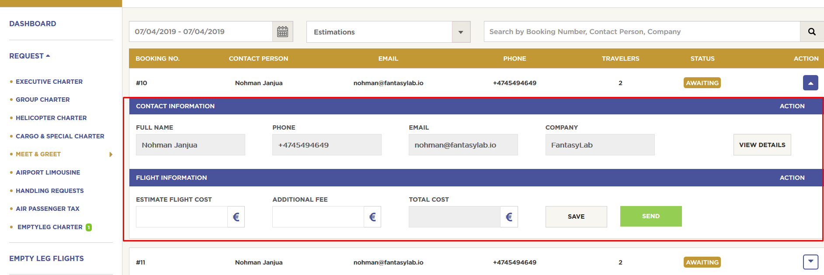

In the section which I have marked with red you can see a “VIEW DETAILS” button. This button can be placed here instead:

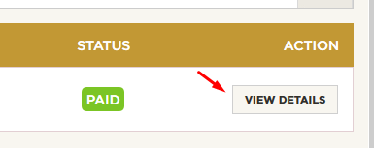

1. On this page: <https://accessoslo.fantasylab.io/contact> when you click “Send Message” 🡪 There is no loader icon appearing inside the button.
2. News page is broken: <https://accessoslo.fantasylab.io/news>
3. The URL of a single article page is wrong. This is the URL for “Supervision of flights in Scandinavia”: <https://accessoslo.fantasylab.io/news/5>

This is how the url should be: <https://accessoslo.fantasylab.io/news/supervision-of-flights-in-scandinavia>

1. These social media icons is not working as they should. Please do QA on this again:

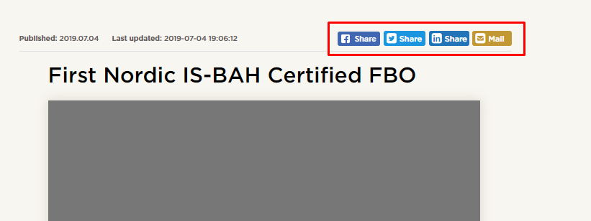

30. On Profile Settings: <https://accessoslo.fantasylab.io/member/profile-settings> I am able to add a Birth of Date which is under 18 years old. That’s not allowed. You must be 18 years old or higher

1. On Login page. When you click “Sign in” button 🡪 There is no loader icon appearing before you get logged in.
2. In admin portal and partner portal when you delete a Fleet from this page: <https://accessoslo.fantasylab.io/admin/aircrafts> a popup must appear: Are you sure you want to delete? Yes/no
3. In Adminpanel 🡪 Customers 🡪 It must be possible to delete a customer also.
4. We need to connect to Live PayPal account. Which information do you need from me to connect to Live PayPal account?
5. Please deactivate this section. We don’t need it now:

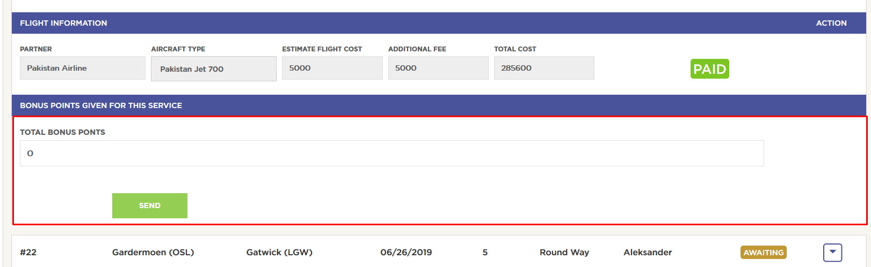

1. Meet & Greet Confirmation email is not showing correct data:

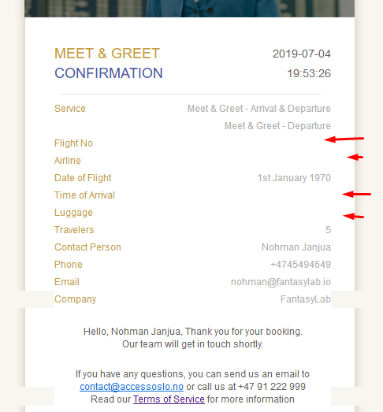

1. When I click SEARCH button on Empty Leg Flights page:

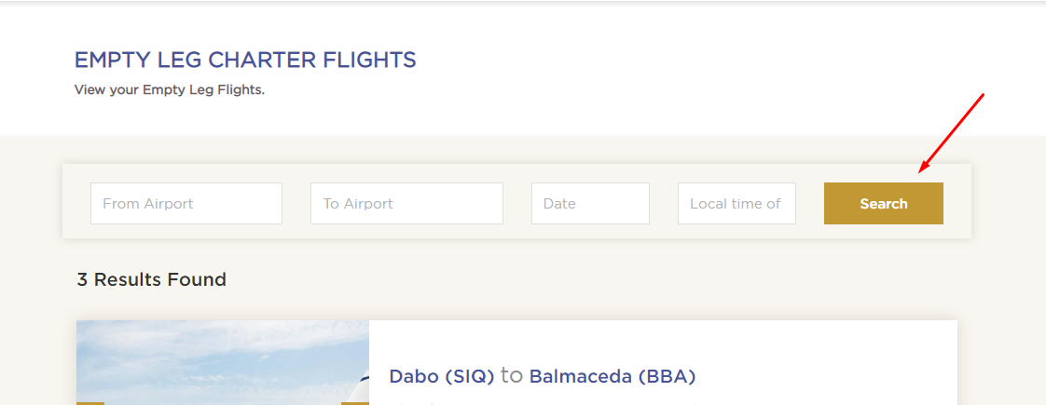

This error appears:

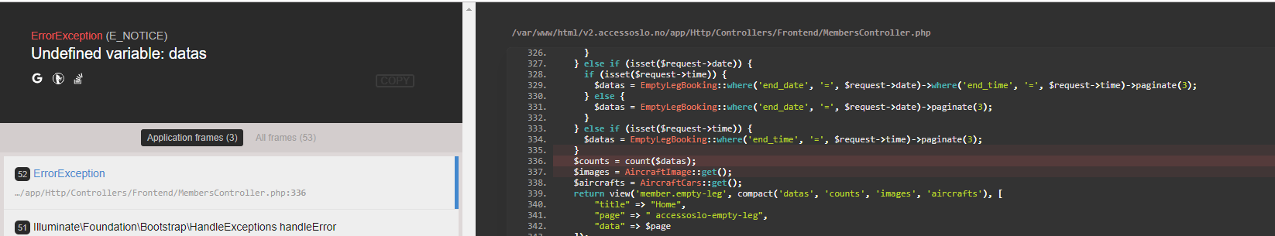

1. On Upcoming Request page. These titles should be font size 18px and the title should be in blue color:

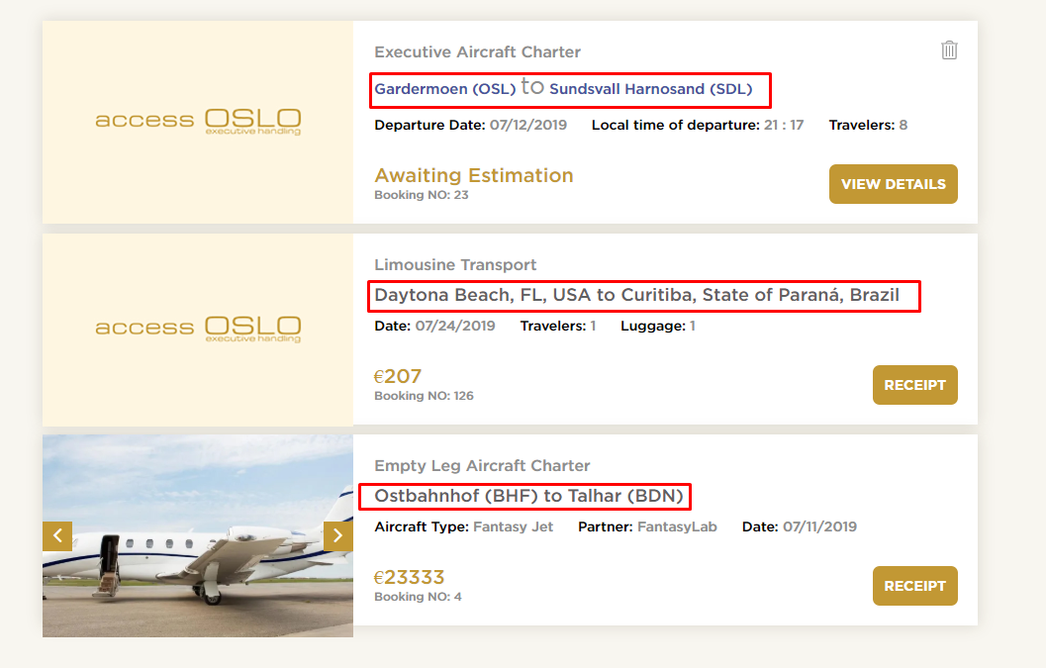

1. When I try to change the password of an existing Partner account. I get this error:

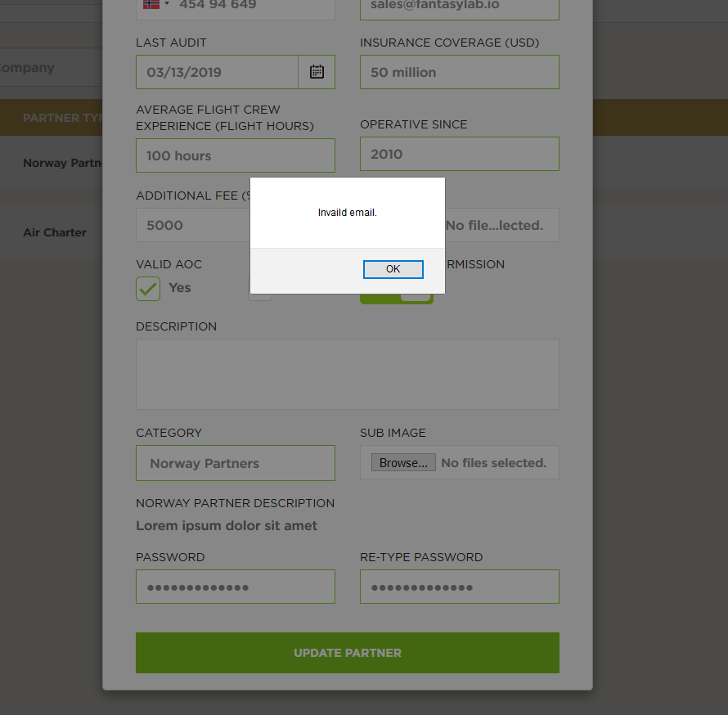

1. I added image for Pakistan Jet 700. But as you can see the image is getting added to the top box and not the bottom box. It should be added to the bottom box:

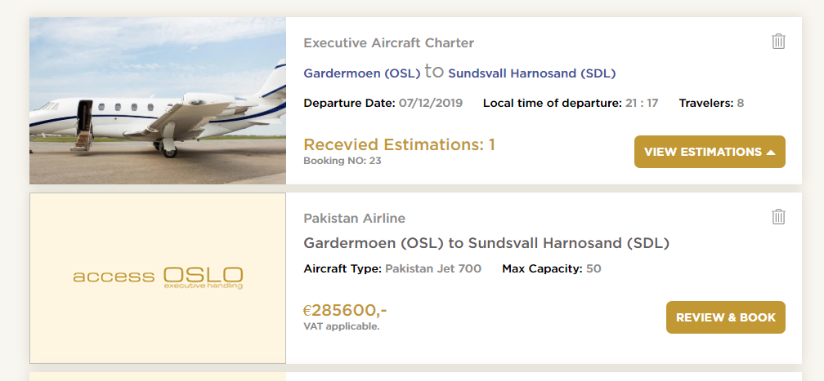

1. Settings page is not working properly. When I change full name or email it does not work. Also the name in right corner does not change:

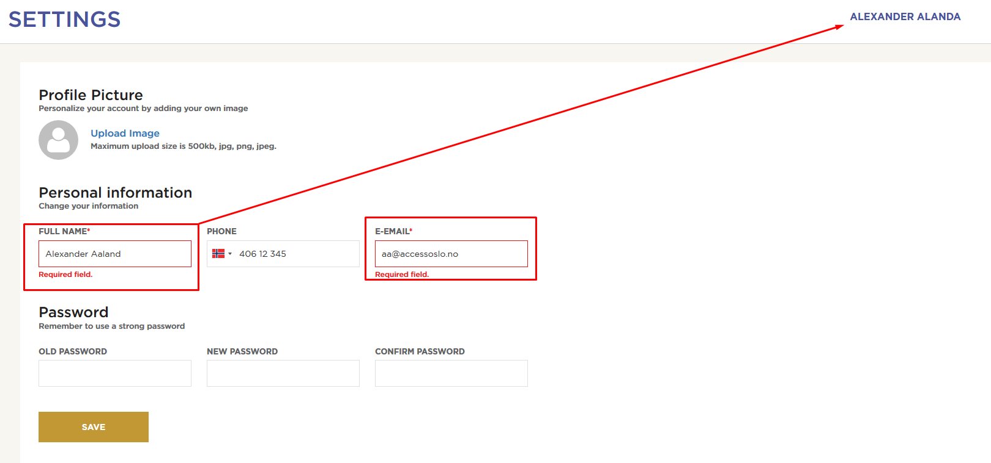

Also This full name should also be changed under Pages here:

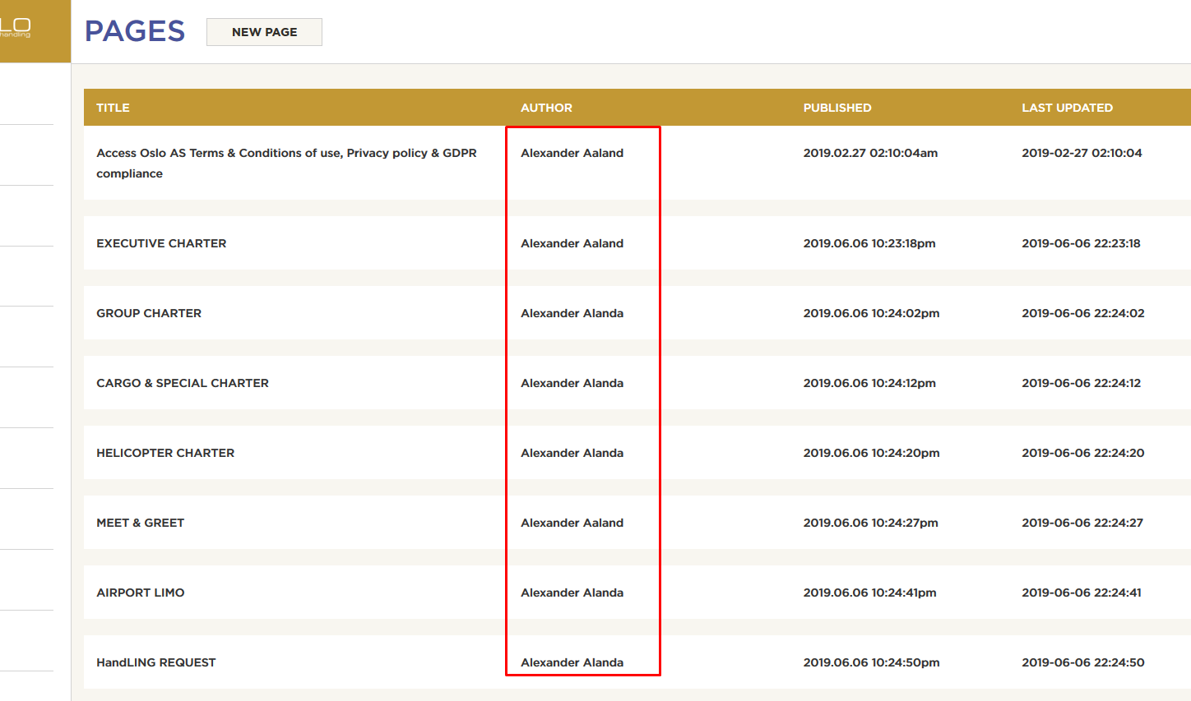

And on Posts page here:

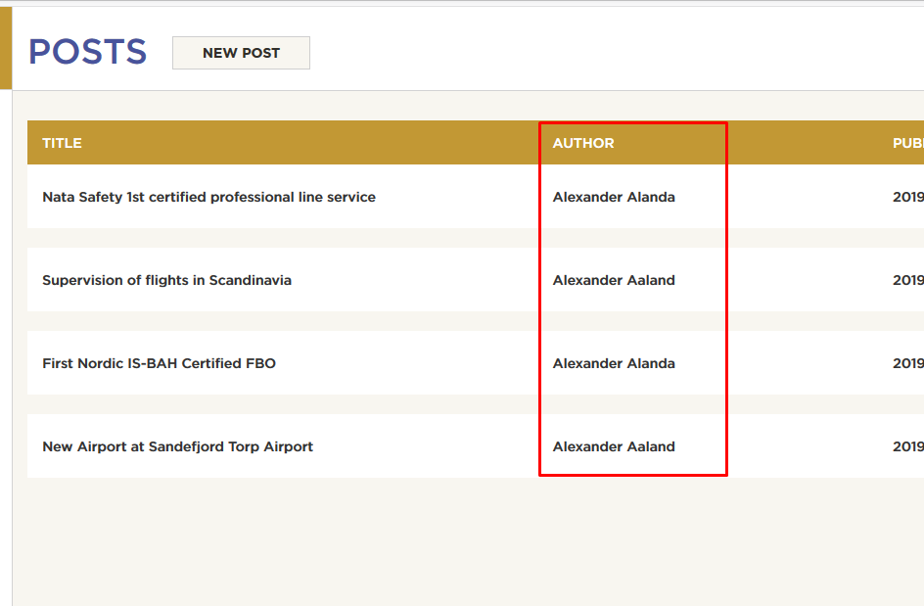

1. For Air Charter we have:
   1. Group Charter
   2. Helicopter Charter
   3. Cargo & Special Charter

When you fill out the forms for the pages above this popup appears:

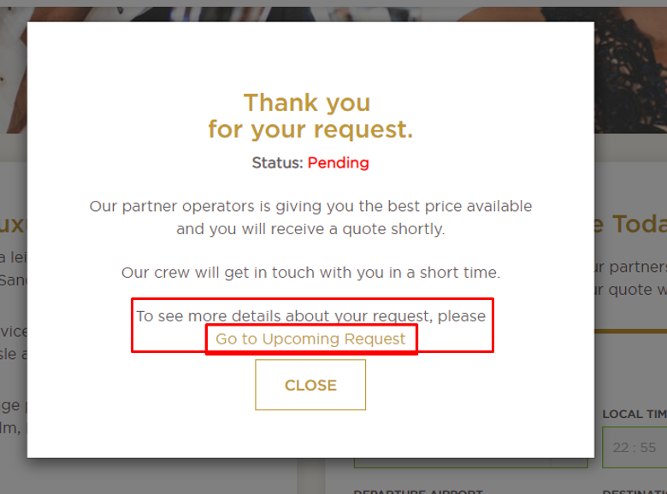

In this popup we need to remove the text marked in red above.

1. Change this to Cargo Charter in adminpanel and partner portal:

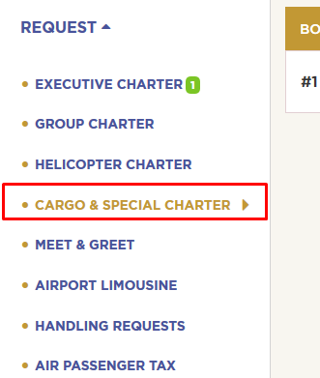

1. Make a new request page is not updated according to the step process popup: <https://accessoslo.fantasylab.io/member/make-request> Can you please update the forms on this page so they have the step process and also same fields ofcourse.
2. Step process is not implemented for Airport Limo from home page:

